
All Saints’ C.E. Primary School
Class Information For
Year
The staff working in your child’s class this term are:
Miss Bell, Mrs Latham (AM), Mrs Foster (PM), Mrs Dixon
(PM) and Mrs Sugathan (Tuesday PM & Friday PM)
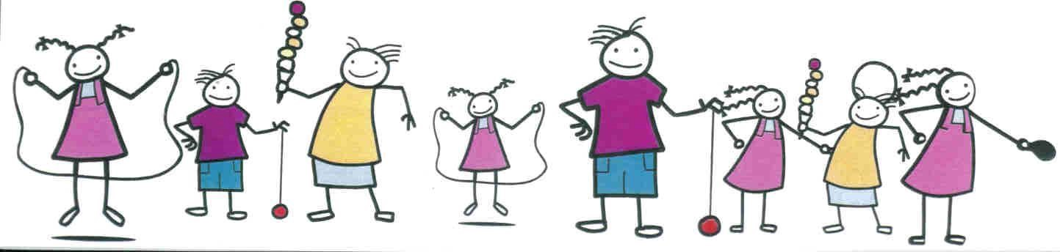

Dear Parents and Carers,
I am very excited to welcome all of the children back into the Year 3 classroom after the Christmas break. We have definitely got a wonderful and fun year ahead and I can’t wait to get started. As some of you know I am new to All Saints and already can’t wait to get stuck in with the wonderful school values and promote Year 3 to be the best they can be!
Over the course of the year we will be looking at developing children’s writing and mathematical skills through a range of interactive and practical tasks. Learning through song will be a big part of our classroom! We will be covering some very interesting units of work which I’m sure the children will be excited to tell you about. Our specialist sport coaches will continue to develop and build the children's skills within sports. This year the children will start a new unit - Modern Foreign Languages where they will begin to learn French, starting with general greetings.
We are looking forward to sharing the amazing things we get up to in Year 3 and you can follow this on Seesaw, Parent Hub and the school website.
If you have any questions or concerns please don’t ever hesitate to get in touch!
Can’t wait to see you all, Miss Bell

General Information

P.E Days
Spring 1: Monday and Friday.
Spring 2: Tuesday and Wednesday.
Children will need to come in their P.E kits on these days please.

Reading

Each child will be given two books per week. One of these is designed to enhance their phonics knowledge and solidify their understanding of key sounds. The other book is for them to share with you to build their comprehension skills. The children will also have access to active learn where there will be a range of books available for them to read.

Homework
In Year 3 the children will be given a manageable amount of homework in line with what they are learning in the classroom. Homework will be set on a Wednesday and to be returned the following Monday. The homework will reflect the English, Maths and science learning. The children will also receive a list of spellings which will also reflect what they have been learning in class.

Subject | Unit
English | Spring 1: In English, we will be reading ‘The True Story of the Three Little Pigs. This book focusses on the wolf’s perspective.  We will explore the features of fairy tale stories, build on comprehension skills and spoken language.  The children will write their own fairy tale story from perspective of another character.
Maths | Spring 1: Year 3 will continue to deepen their knowledge on their times tables. They will be focussing more on 3, 4- and 8-times tables and also learning how to divide.  Spring 2: We start to look at length and perimeter. The class will have the opportunity to measure different items and add and compare lengths.
Science | Spring 1: In science we will we learning about light and dark. This topic will cover what dark is (in relation to absence of light), that we need light so we can see things, how light can be reflected, how a shadow is formed and why they change shape.  Spring 2: What do we mean by force? We will look at how different surfaces speed thing up or slows things down, know what a pulley is and how it works and know how magnets work.
History | Throughout Spring 1 Year 3 will be exploring the life of the Mayans. Some of the main topics the children will explore are; What was happening in Britain when the Mayans were most powerful? How different are the Mayans and the Egyptian pyramids?
Geography |  | In Spring 2 we will move to our geography topic and explore ‘How is a River formed?’ (Including rivers in the UK and the world plus the Water Cycle).
RE |  | Throughout Spring 1 Year 3 will explore the question ‘How do festivals and worship show what matters to a Muslim?’  Within Spring 2 we will explore the question ‘How do festivals and worship show what matters to Jewish people?’

