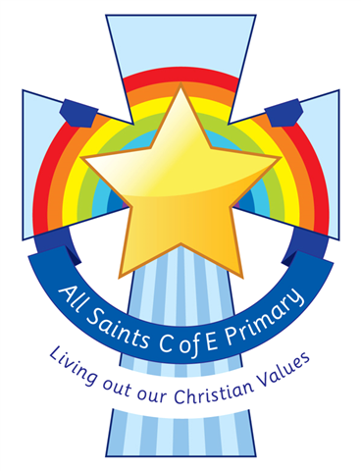
All Saints’ C.E. Primary School
Class Information For
Year
The staff working in your child’s class this term are:
Miss Bell, Mrs Latham (AM), Mrs Foster (PM), Miss Dixon(PM) and Mrs Garner (Tuesday PM & Friday PM)
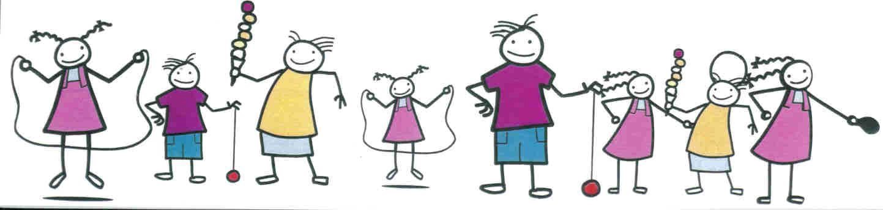

Dear Parents and Carers,
I am very excited to welcome all of the children back into the Year 3 classroom after the Easter break. All of Year 3 have made fantastic progress so far this year and I’m sure they will continue to excel throughout this last term.
Throughout the rest of the year we will continue to look at developing children’s writing and mathematical skills through a range of interactive and practical tasks. Learning through song will be a big part of our classroom! We will be covering some very interesting units of work which I’m sure the children will be excited to tell you about. Our specialist sport coaches will continue to develop and build the children's skills within sports. This year the children will start a new unit - Modern Foreign Languages where they will continue to build on their French knowledge.
We are looking forward to sharing the amazing things we get up to in Year 3 and you can follow this on Parent Hub and the school website.
If you have any questions or concerns please don’t ever hesitate to get in touch!
Can’t wait to see you all, Miss Bell

General Information

P.E Days
Summer 1: Tuesday and Friday.
Summer 2: Tuesday and Thursday.
Children will need to come in their P.E kits on these days please but bring their trainers in a sperate bag to change into.

Reading
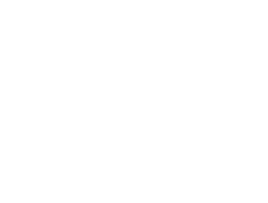
Each child will be given two books per week. One of these is designed to enhance their phonics knowledge and solidify their understanding of key sounds. The other book is for them to share with you to build their comprehension skills. The children will also have access to active learn where there will be a range of books available for them to read.

Homework
In Year 3 the children will be given a manageable amount of homework in line with what they are learning in the classroom. Homework will be set on a Wednesday and to be returned the following Monday. The homework will reflect the English, Maths and science learning. The children will also receive a list of spellings which will also reflect what they have been learning in class.

Subject | Unit
English | Spring 1: In English, we will be reading ‘The Street Beneath my Feet’. This book explores discovers all the things that are happening below us all the way to the centre of the earth. We will be using poetry to further our understanding and performing towards the end!  Summer 2: One plastic bag will be our book focus this half term. This explains the importance of recycling and the pollution to the planet.
Maths | Summer 1: Year 3 will continue to deepen their knowledge on length and perimeter. We will also begin learning about time. We will continue to focus on times tables as well.  Summer 2: We will continue with time and then move back onto multiplication and division, followed by fractions.
Science | Summer 1: In science we will we be continuing with forces and magnets but focusing on building a pulley to lift up an object.  Summer 2: We will be exploring the human body within the last term. Delving deeper into skeletons and muscles.
History | Throughout Summer 1 Year 3 will be learning about the History of Bury. We will explore the Industrial Revolution and what Sir Robert Peel did for the United Kingdom.
Geography | In Summer 2 we will explore the difference of living in the UK and France. We will explore the difference in climate, what the famous landmarks of both countries are and differences in language, food and currency etc.
RE | This half term in RE we will be focusing on the question ‘What do Christians learn from the Creation Story?’. This unit focuses on the stories of Creation and the Fall as two parts of the ‘Big Story’ of the Bible.  Summer 2 we will explore the question ‘How and why do people try and make the world a better place?’.

